2022-2023 School Supplies – Grade 6
Glen Allan Elementary

PLEASE LABEL THE FOLLOWING SUPPLIES:
- 1 Daily agenda
All students require a daily agenda for communication purposes. The school will continue to have agendas available for purchase in September with an approximate cost of $5
- 1 Pair of indoor runners
All students will require one pair of good running shoes for indoor use. Footwear which marks or damages the floor will not be permitted. NO platform soles, heelies or backless runners please.
- 1 Pencil case to hold pencils, markers, etc. (pencil boxes do not easily fit into our desks)
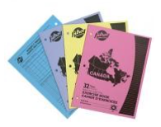
- 20 HB Staedtler pencils (sharpen much better; please pre-sharpen but do not label)
- 4 White Eraser
- 5 Ballpoint pens (not black please)
- 2 Highlighter (different colors)
- 4 Exercise books (as pictured)
- 1 Pencil sharpener with lid
- 1 Mr. Sketch markers (last longer than other brands; work well for posters)
- 1 Pencil crayons 24 pk
- 1 Pointed scissors
- 1 Pair of earbuds or headphones (clearly labeled – in a Ziplock)
- 15 Duo tangs (We have chosen specific colors to help students stay organized via subject)
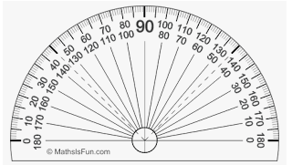
5 each – red, green, orange
- 2 Glue Sticks (40g)
- 1 Ruler - clear plastic (metric only – marked in cm)
- 1 Lined loose-leaf pk
- 2 Dividers – 8 tab
- 2 4” protractor - clear plastic (please do not bring the whole geometry set)
- 2 1 1/2” binder (1 red, 1 black)
We have chosen specific colors to help students stay organized via subject.
- 1 Basic calculator (not scientific)
- 1 Indoor running shoes

** Please save a shoe box for later in the year!

PLEASE LABEL ALL SUPPLIES WITH STUDENT NAME

