2022-2023 School Supplies – Grade 2
Glen Allan Elementary
PLEASE LABEL THE FOLLOWING SUPPLIES:
- 1 Daily agenda
All students require a daily agenda for communication purposes. The school will continue to have agendas available for purchase in September with an approximate cost of $5
- 1 Pair of indoor runners
All students will require one pair of good running shoes for indoor use. Footwear which marks or damages the floor will not be permitted. NO platform soles, heelies or backless runners please.
- 1 Medium tip markers pk
- 2 Highlighter
- 1 Staedtler pencil sharpener with lid
- 1 Pencil crayons 24 pk
- 1 Wax crayon 24 pk
- 1 Hard pencil box or large pencil case
- 1 Pointed scissors
- 1 Set of headphones (no earbuds) clearly labeled – in a Ziplock
- 1 Home reading pouch
- 1 Indoor running shoes
- 1 Ruler

PLEASE DO NOT LABEL THE FOLLOWING SUPPLIES (they will be shared):
- 4 White Eraser
- 4 Whiteboard markers for use on individual whiteboards
- 10 Duo tangs (no plastic please)
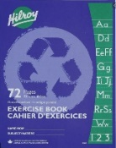
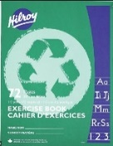
- 4 Glue Sticks (40g)
- 2 Green exercise books (½ blank, ½ interlined)
- 2 Blue exercise books (fully interlined)
- 24 Staedtler pencils (sharpen much better; please pre-sharpen)
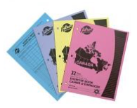
- 2 Pads of sticky notes (3” x 3”)
- 2 Pocket folders
- 1 Exercise book (as pictured)

Please send all supplies on the first day of school. They will be stored for your child’s use. Unused supplies will be sent home at the end of the year.

