2022-2023 School Supplies – Grade 1
Glen Allan Elementary

PLEASE LABEL THE FOLLOWING SUPPLIES:
- 1 Daily agenda
All students require a daily agenda for communication purposes. The school will continue to have agendas available for purchase in September with an approximate cost of $5
- 1 Pair of indoor runners
All students will require one pair of good running shoes for indoor use. Footwear which marks or damages the floor will not be permitted. NO platform soles, heelies or backless runners please.
- 1 Hard pencil case
- 1 Set of headphones (no earbuds) clearly labeled – in a Ziplock
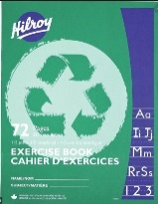
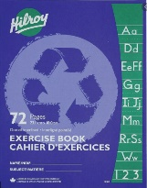
- 1 Home reading pouch
- 2 Green exercise books (½ blank, ½ interlined)
- 1 Blue exercise book (fully interlined)
- 1 Indoor running shoes
- 1 Pencil Sharpener

PLEASE DO NOT LABEL THE FOLLOWING SUPPLIES (they will be shared):
- 10 Duo tangs (plain, no design, no plastic please)
1 each color - dark blue, purple, orange, grey
2 each color - yellow, red, green
Please do not purchase any other color as subject areas are color coordinated.
- 4 White Eraser
- 24 Staedtler pencils (sharpen much better; please pre-sharpen)
- 1 Pencil crayons 24 pk
- 4 Glue Sticks (40g)
- 1 Scissors (small sharp pointed)
- 1 Wax crayon 24 pk
- 2 Highlighter (wide tip)
- 1 Wide tip markers pk
- 4 Whiteboard markers for use on individual whiteboards

Please send all supplies on the first day of school. They will be stored for your child’s use. Unused supplies will be sent home at the end of the year.

