2022-2023 School Supplies – Kindergarten
Glen Allan Elementary

- 2 Whiteboard markers for use on individual boards (chisel tip)
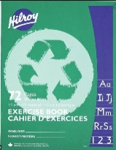
- 1 1.5” binder
- 2 Duotangs (plain colors – no navy or black)
- 1 White Eraser
- 2 Green Exercise Books (½blank, ½ interlined)
- 1 Crayola Fine tip washable marker 12 pk
- 2 Ticonderoga “My first Tri-Write” pencils
- 1 Crayola wax crayons 24 pk
- 4 Elmer’s 20g “disappearing purple” glue sticks
- 1 Storex or other hard pencil case
- 1 Fiskars 6” pointed end scissors
- 1 Set of headphones (no earbuds) clearly labeled – in a Ziplock
- 1 Indoor running shoes

** All students will require one pair of good running shoes for use indoors.
Footwear which marks or damages the floor will not be permitted –
NO PLATFORM SOLES, HEELIES OR BACKLESS RUNNERS, PLEASE.

