2021-2022 School Supplies – Grade 6
Glen Allan Elementary
PLEASE LABEL THE FOLLOWING SUPPLIES and put into a pencil case:
- 1 Pencil case to hold pencils, markers, etc. (pencil boxes do not easily fit into our desks)
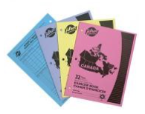
- 20 HB Staedtler pencils (sharpen much better; please pre-sharpen but do not label)
- 4 White Eraser
- 5 Ballpoint pens (not black please)
- 2 Highlighter (different colors)
- 4 Exercise books (as pictured)
- 1 Pencil sharpener with lid
- 1 Mr. Sketch markers (last longer than other brands; work well for posters)
- 4 Whiteboard markers for use on individual whiteboards
- 1 Pencil crayons 24 pk
- 1 Pointed scissors
- 1 Pair of earbuds or headphones (clearly labeled – in a Ziplock)
- 15 Duo tangs (We have chosen specific colors to help students stay organized via subject)
  - 5 each – red, green, orange
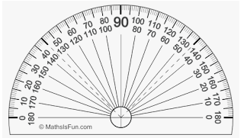
- 2 Glue Sticks (40g)
- 1 Ruler - clear plastic (metric only – marked in cm)
- 1 Lined loose-leaf pk
- 1 Grid paper (1cm x 1cm) pk
- 2 Dividers – 8 tab
- 1 4” protractor - clear plastic (please do not bring the whole geometry set)
- 2 1 1/2” binder (1 red, 1 black)
  - We have chosen specific colors to help students stay organized via subject.
- 1 Basic calculator (not scientific)
- 1 Indoor running shoes
** All students will require one pair of good running shoes for use indoors.
Footwear which marks or damages the floor will not be permitted –
NO PLATFORM SOLES, HEELIES OR BACKLESS RUNNERS, PLEASE.
** Please save a shoe box for later in the year!

PLEASE LABEL ALL SUPPLIES WITH STUDENT NAME

