2021-2022 School Supplies – Grade 2
Glen Allan Elementary

PLEASE LABEL THE FOLLOWING SUPPLIES:
- 4 Whiteboard markers for use on individual whiteboards
- 1 Thin tip markers pk
- 2 Highlighter
- 1 Staedtler pencil sharpener with lid
- 1 Pencil crayons 24 pk
- 1 Wax crayons 24 pk
- 2 Pads of sticky notes (3” x 3”)
- 1 Hard pencil box or large pencil case
- 1 Pointed scissors
- 1 Set of headphones (no earbuds) clearly labeled – in a Ziplock
- 1 Home reading pouch
- 1 Indoor running shoes

** All students will require one pair of good running shoes for use indoors.
Footwear which marks or damages the floor will not be permitted –
NO PLATFORM SOLES, HEELIES OR BACKLESS RUNNERS, PLEASE.

PLEASE DO NOT LABEL THE FOLLOWING SUPPLIES (they will be shared).
- 4 White Eraser
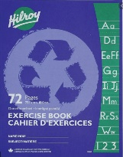
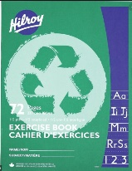
- 8 Duo tangs (no plastic please)
- 4 Glue Sticks (40g)
- 3 Green exercise books (½ blank, ½ interlined)
- 3 Blue exercise books (fully interlined)
- 24 Staedtler pencils (sharpen much better; please pre-sharpen)
- 2 Pocket folders

Please send all supplies on the first day of school. They will be stored for your child’s use. Unused supplies will be sent home at the end of the year.

