2021-2022 School Supplies – Grade 1
Glen Allan Elementary

PLEASE LABEL THE FOLLOWING SUPPLIES:
- 10 Duo tangs (plain, no design, no plastic please)
  - 1 each color - dark blue, purple, orange, grey
  - 2 each color - yellow, red, green
  - Please do not purchase any other color as subject areas are color coordinated.
- 1 Hard pencil case
- 1 Set of headphones (no earbuds) clearly labeled – in a Ziplock
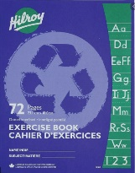
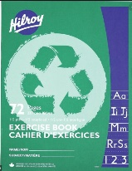
- 1 Home reading pouch
- 2 Green exercise books (½ blank, ½ interlined)
- 1 Blue exercise book (fully interlined)
- 1 Indoor running shoes

** All students will require one pair of good running shoes for use indoors.
Footwear which marks or damages the floor will not be permitted –
NO PLATFORM SOLES, HEELIES OR BACKLESS RUNNERS, PLEASE.

PLEASE DO NOT LABEL THE FOLLOWING SUPPLIES (they will be shared).
- 4 White Eraser
- 24 Staedtler pencils (sharpen much better; please pre-sharpen)
- 1 Pencil crayons 24 pk
- 4 Glue Sticks (40g)
- 1 Scissors (small sharp pointed)
- 1 Wax crayons 24 pk
- 1 Highlighter (wide tip)
- 1 Thin tip markers pk
- 2 Whiteboard markers for use on individual whiteboards

Please send all supplies on the first day of school. They will be stored for your child’s use. Unused supplies will be sent home at the end of the year.

