# Glen Allan School Council Meeting – Virtual Platform

**April 15, 2021**

**6:30 - 8:15 p.m.**

**In Attendance:**

Judy Anderson, Dustine Vicic, Jeremy Albert, Stacey Robinson, Ryan Fukala, Marcie Evanochko, Erin Barrett, Don Irwin, Kersten Morris, Jenn Campbell, Irene Hamm, Sherry Coombes, Jessica Winship

**Regrets**: Sheila Connolly

1. The general meeting was called to order at 6:32 p.m. by Chair, Jessica W.
2. **Welcome and Introductions**

Jessica W. welcomed everyone to the meeting. Roundtable introductions.

1. **Approval of February 18, 2021 Minutes**

**Motion**: Jenn C. made motion to approve the February 18, 2021 minutes as is. Erin B. seconded. Motion carried.

1. **EIPS Trustee Report – Don Irwin**

* The school board has held meetings throughout March and April to finalize details for the 2021/2022 budget. Details will be finalized by the end of May.
* EIPS to hire three temporary Family service workers to try and track down missing students in the district.
* EIPS to discontinue online learning next year, however, homeschooling will be available for one more year for families who are unable to attend in person.
* No technology fee is proposed for next year as we are evaluating the budget and determining the technology needs for next year and the future.
* Six modular are being relocated within the district. Four will be moved from Campbelltown to South Pointe and two from Pine Street to Ardrossan. This will reduce capacity in Sherwood Park which will improve our chances of replacing Sherwood Heights.
* The draft curriculum has been released and we will be reviewing it carefully and giving input to the government. At our monthly COSC meeting our superintendent Liguori recommended that we read the guiding framework and the competency documents before reading the curriculum itself. These documents can be found on the Alberta Education Provincial education website.
* EIPS has decided not to pilot the proposed new curriculum as families and staff are busy with COVID measures and we want next year to be as normal as possible after two challenging and disruptive years. We want to focus on eliminating student learning gaps from the past two years.
* Link to the draft curriculum [https://www.alberta.ca/curriculum.asp](https://na01.safelinks.protection.outlook.com/?url=https%3A%2F%2Fwww.alberta.ca%2Fcurriculum.aspx&data=04%7C01%7C%7Cdcf524e59bf24c53a23908d9006ff7fd%7C84df9e7fe9f640afb435aaaaaaaaaaaa%7C1%7C0%7C637541303157479830%7CUnknown%7CTWFpbGZsb3d8eyJWIjoiMC4wLjAwMDAiLCJQIjoiV2luMzIiLCJBTiI6Ik1haWwiLCJXVCI6Mn0%3D%7C1000&sdata=1HY31diTEr5Uf2FBbL5P5zrAXTfyw24VjzwlLZXCDNI%3D&reserved=0)
* If you have questions, suggestions, or input on any topic, please contact me on my cell at 587 986 3900 or email me at [don.irwin@eips.ca](mailto:don.irwin@eips.ca).

1. **Introduction and Land Acknowledgement – Jeremy Albert, First Nations, Métis, and Inuit Educational Advisor, EIPS**

* Jeremy introduced himself and shared some information about his culture and work with Glen Allan Elementary and EIPS which includes teacher training, working with students and resource development.
* Jeremy also provided some background on land and people acknowledgement and how it’s use demonstrates respect and reconciliation.
* Treaty 6 land and territory is acknowledged throughout EIPS Schools.
* As well, the Treaty 6 flag is raised at various places in the region, including the City of Edmonton, Strathcona County and the RCMP headquarters in Edmonton.
* Judy shared that the land and people acknowledgement is part of annonucments at the school on Thursdays.
* **Action** **Item**: Glen Allan School Council will start using the land and people acknowledgement at its May 19th meeting and for future meetings.

1. **Principal’s Report – Judy Anderson**

* (AP 505)– School Fee Consultation – Fee Submission

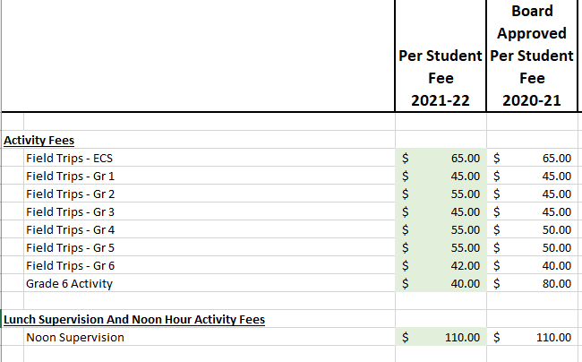

* Any of the increases reflect doing 2-3 field trips with potential of increased admission costs.
* **May Meeting moved to May 19 at 6:30 p.m**. – Roles of GASC paper copy going home on Monday, April 19 to every family.
* **Surveys**
  + EIPS Parent Survey remains open until April 20, 2021 – your feedback is greatly appreciated!
  + Alberta Education Assurance Survey is for Grade 4 students and parents which remains open until April 23, 2021.
  + Curriculum Feedback Survey - [https://www.alberta.ca/curriculum.asp](https://www.alberta.ca/curriculum.aspx)

1. **Vice Principal’s Report - Dustine Vicic**

* FNMI Giant floor map
* Blanket exercise Grade 5
* Trips to the forest
* Thank you to GASC for the library furniture, books and LLI Kit.

1. **Teacher Report – Stacey Robinson**

* February theme – Choose kind.
* Grade 5 weather watch from Global News
* Minecraft EDU - grade 6s began this week.
* Battle of the Books – in school version. Miss Gauchier and Mrs. Miles de Silva
* Grade 6 DARE Grad – April 16
* House points – expanding Grade 1 & 2 Panda Points
* GASC – thank you for supporting one virtual field trip/class.

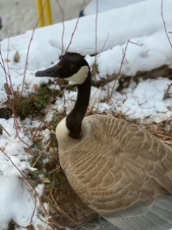

1. **School Council Updates**

*Programs Vice-Chair Updates – Sheila Connolly*

* Yearbook – update provided by Judy who has been working with the yearbook coordinator Gina H. Sherry C. has kindly offered to take on the yearbook coordination next year and has been working with Gina.

*Fund Development Committee Chair Updates – Jenn Campbell*

* Spring Virtual Book Fair – Feb 22 – Mar 8
  + $783 sales
  + Glen Allan received 20% profit from the sales which equaled $150, which allowed Miss Gauchier to purchase additional books for the school library.
* Staff Appreciation Options
  + Italian Centre has confirmed they can do individual charcuterie boxes at $20 per box. Jenn will work with Michelle R and Judy to proceed with this option.

*Budget Vice-Chair Updates – Erin Barrett*

* Erin presented an update on the current financial status of the council.

*Chair Updates - Jessica Winship*

* + April 7, 2021 COSC Meeting Update
    - <https://www.eips.ca/parents/committee-of-school-councils-cosc>
  + Jessica encouraged parents to provide their input to the K-6 Draft Curriculum and highlighted various feedback opportunities, noting the parent voice is very important.
  + The 2021/22 GASC Elections will be held at our May 19 meeting. All positions are open, with active recruitment to the Secretary and Chair positions. Glen Allan parents are encouraged to put their name forward or nominate someone.
  + Update that GASC is continuing to work on a financial guidelines/tip sheet around the usage of money and volunteer roles. The goal is not to make it onerous but to provide some helpful information.
  + Last meeting of the year is Wednesday, May 19.

1. **Parent Feedback/Suggestions**

- No items.

Meeting adjourned at 7:35PM. Next meeting May 19, 2021 via virtual platform.